HND HCI and develop interactive media website | January 1  2014
This document is to be used as a reference to guide you through the project making sure you achieve all parts of all outcomes for all the units. |  | iCinema website – Individual project

Contents
Overview 4
Units and outcomes covered 4
Unit Flow 4
Emphasis of the project 4
The Brief 5
Analysis of the brief 6
User Analysis 6
User environments and platforms 6
Task Analysis 9
Design Implications 13
Design implications 13
Development model 14
Designing the Prototype 14
Navigation map 16
Storyboards 17
Prototype Development 17
Usability evaluation of prototype 18
Usability Evaluation Plan 18
Purpose of the Usability Evaluation 18
Usability Evaluation Strategy 19
Usability Performance Goals 19
Setting up the usability evaluation session 19
Usability Evaluation Sample 19
How the evaluation will be conducted 19
Post Test Deliverables 20
Questionnaire results : 20
Question 1: How difficult was it to navigate to your desired page? 20
Question 2 : if you could improve the website in one way what would you do ? (answers on next page) 21
Question 3 how easy/difficult was it to register with the website? 21
Question 4 : how easy/difficult was it to log in ? 22
Question 5: was the font easy to read? 22
Question 6: How responsive was the website as a whole? 23
Question 7: What age group do you fall into ? 23
Analysis of the data collected 24
Usability Change Log 24
Development of the product 26
Management of project files 26
Debug and test 27
Publish and Test 28
Test Strategy 28
Navigation testing 28
Cross browser testing 29
Platforms 29
Screens 29
Test Plan 29
Publish the product 30
User-guide 30
Test the published product 31
Evaluation 33
Evaluation of the end product 33
Self-reflection - Evaluation of the project 33
Evaluation 33
Evaluating the final product 34
Evaluating the project 35
Evaluation Words 36
Submission Check List 36

The Brief

iCinema have commissioned you to design and develop an interactive website specifically for them. There are approximately 15 cinema clubs in Midlothian. They would like a website for members, junior members (16 and under) and the staff. At present there is a national website; however it is felt that it would be beneficial to have an additional smaller site to cater for this particular locale, especially as they wish to have a function that allows ticket stock control and registration of members. There should be a facility included so that users can print off 'showing' information, if they so wish.
The junior members would like a website where they can find out about all the age suitable films. They would also like a facility to search for suitable films. In addition, they have asked for a games page that contains at least one quiz based on movies.
The adult members would like to find general information on the club as well as access to the showing times. Adults need the opportunity to register as a member as they need to be able to login to book tickets (no payment system is required).
Club staff require access to all areas of the website. They must be able to log in and find information on all members who are registered. The type of information required would include their contact details and the membership type. They should also have access to delete or modify member information, to create, update event information and event ticket numbers. It would be beneficial if they could upload pdf newsletters to the website.
Additionally the website must be designed to appeal to, and be easy to use by, the target audience. The website should be designed to be fully accessible on standard PCs/laptops as well as on mobile devices which may mean two separate websites are required. Form validation and error handling or user feedback should also be included in the websites functionality. It is vital that the website complies with current web standards for accessibility, usability, and coding.

Analysis of the brief

User Analysis

User environments and platforms

Platforms | Pc, Mac, Mobile
Browsers | Mozilla Firefox, Google Chrome, Internet Explorer, Safari, Opera
Operating Systems | Mac OS, Windows, Linux
Internet Connection | Broadband, 3g
Screen Resolution | 1080p, 720p,
Access | The website will be accessible from most areas such as home, library, school and work although in some of these cases this would be at the discretion of the institution.
Possible Plugins | Flash, Adobe Reader, Java

User type | Expectations
Adult | - Should be able to view general information regarding the club  - Able to view showing times  - Able to register as a member  - Registration is required to book tickets  - Expect the website to be in English  - The language isn’t too technical  - Feedback is provided when data is entered by the user  - System status is visible
Junior | - Able to find age suitable films  - Facility to search for suitable films  - Games page which includes at least one quiz based on movies  - Expect the website to be in English  - Expect the website to be easy to use  - The language isn’t too technical  - Easy to read font  - Minimalist design
Staff | - Able to log in and view registered members  - Able to view contact details and membership type  - Able to create, update event information  - Able to update event ticket numbers  - Able to upload pdf newsletters  - Expect the website to be in English  - easy to use interface for adding films  - fast loading time for website

Persona 1(adult)

Name: Jim Davidson
Nationality: Scottish
Occupation: Factory Worker
Age: 45
Gender: Male
Family status: Married, Two kids
Interests: Fishing, movie enthusiast, golf
Reasons for visiting website: Wants to book a ticket to go see a new film
Personality: Sociable, humorous.
Tasks: check ticket prices, ticket stock, seating availability, popcorn and drinks prices, film age ratings, film reviews, film descriptions. Not allowed to access staff only parts of website.
Booking tickets doesn’t have to be an online method, could use box office.
Computer literacy level: Average. Sells items on Ebay.

Persona two (child)

Name: Timmy Davidson
Age: 7
Occupation: Primary School
Gender: Male
Family status: Parents, One sibling
Interests: Video games, football, cartoons.
Reasons for visiting website: To play online games.
Personality: hyper, sociable.
Tasks:
- view age suitable trailer
- Play a game within the website.
- Search for age suitable films.
Computer literacy level: Can operate programs such as word, google chrome, is a regular surfer of the internet and gamer.

Persona 3 (staff)

Name: Steve Williams
Age: 30
Occupation: Programmer
Gender: male
Family status: Married, No kids
Interests: Video games, Movies, music, programming
Reasons for visiting website: Managing website by creating new information about new movie releases
Tasks:
- Login as admin
- Add film to the database

Computer literacy level: high, can program in 5 different languages

Task analysis

The task | User type | Current Method | Proposed Method
Register as a member | Adult | Access a form and fill in details such as name, d.o.b , e-mail address | 1.Access homepage  2.Click register  2.1 click form box labelled name  2.2 enter name into form box  2.3 press tab to select next form item  2.4 select date of birth using drop down  2.5 press tab to select next form box  2.6 enter email address into form box  3. click submit to register  4.Recieve a confirmation e-mail or a message which confirms completion of registration
View ‘showing’ information | Adult | Access ‘showings’ page via hyperlink | 1.access homepage  2. click link to ‘showings’ page  3. click desired film category  4. select desired film  5. click ‘showing’ info button  6.description of film displays
Print off showing information | Adult | Access ‘showings’ page, if print button is clicked the selected showing is printed as a paper copy | 1.access homepage  2. click ‘showings’ page  3.select desired film  4. click ‘showing’ information  5. click print icon  6.show message of confirmation that the print was successful
Access ticket stock control | Staff | Should require the user to log in, to allow access to admin abilities, | 1. access website via browser.  2. click the link to admin login located in the footer  3. click the text box labelled username  4.type a valid admin username  5. click the text box labelled password  6.type in a valid admin password  7.click submit  8.The ticket stock control should now be displayed  9.To edit the number of tickets available:  9.1 select the film which is required to be updated by clicking the dropdown labelled film title.  9.2 click the text box labelled “number of tickets”  9.3 enter the number of tickets available for the selected film  9.4 click the button labelled update  9.5 a message should appear saying “Ticket stock updated”
View registered members contact details | Staff | Requires user to log In with admin level details which allows the user to access contact details page. | 1.enter website via browser  2. locate admin login hyperlink  3. click admin login hyperlink  4. click username text field  5. enter admin username  6.click password text field  7. enter admin password  8. click submit  9.the website should redirect to admin control panel  10. a new link labelled “customer details” will appear in the navbar  11. click this link  12. from this page member details can be viewed and deleted from the database
Add event to database | Staff | Log in as admin to enter events page and add event information. | 1.enter website via browser  2. click admin login hyperlink located in the footer  3.click username text box  4.enter admin username  5.click password text box  6.enter password into password text box  7. click login  8.website will re-direct to control panel  9. click event title text field  9.1 enter title of event  9.2 click tickets form field  9.3 enter number of tickets available  9.4 click event date text field  9.5 enter the date of the event  9.5 click the age rating form field  9.6 enter the age rating of the film  10. click add film to add the film to database  11. the website should display all available details of the event  12. select the detail which is desired to be edited by clicking it.
Access film quiz game | Junior | Enter site via browser,  Click link to games and then click the game to start playing | 1.enter website address to access homepage  2.click link to games page  3.click quiz  4.play game
Search for an age suitable film | Junior | Enter site via browser,  Click search bar, click age filter and enter a search term | 1.Enter website  2. if user isn’t logged in, require d.o.b input via dropdown selection  3. if user is under 16 only show age appropriate films
Facility to find information on junior films | Junior | Enter website via browser,  click films, click film description | - enter website  - if user isn't logged in, require d.o.b. Input via dropdown  - navigate to films page  - click desired film to view description

Design implications

User type | Expected design elements
Adult | - Easy navigation  - Form feedback  - Text easy to read  - Access to information regarding showings  - A search facility  - Alt tags  - Compatibility with most browsers  - Mobile compatibility  - Easy to read text  - Detailed information
Junior | - Colourful design  - No jargon  - Easy to navigate  - Search facility  - Alt tags  - Access to showing information  - Easy to read text  - Less detailed information (straight to the point)  - The text should be in English
Staff | - Log in facility  - Extra functionality compared to general user  - Should be able to upload pdf newsletters  - Easy to read text  - The ability to add films to the film database  - Separate login facility from the other user types  - Technical jargon where required  - Access to member contact details

Development model

I decided Waterfall model would be most effective because it allows for changes to be made within the development stage quickly. This will most likely be required as changes will need to be made if part of the product isn't functioning properly.

project plan

Early stage

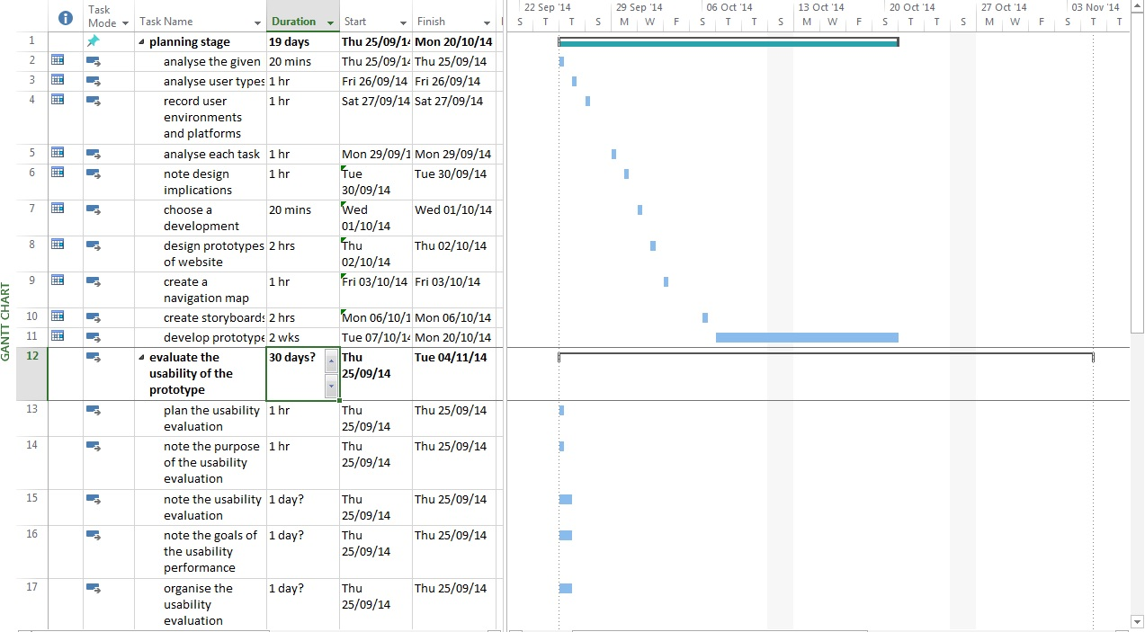
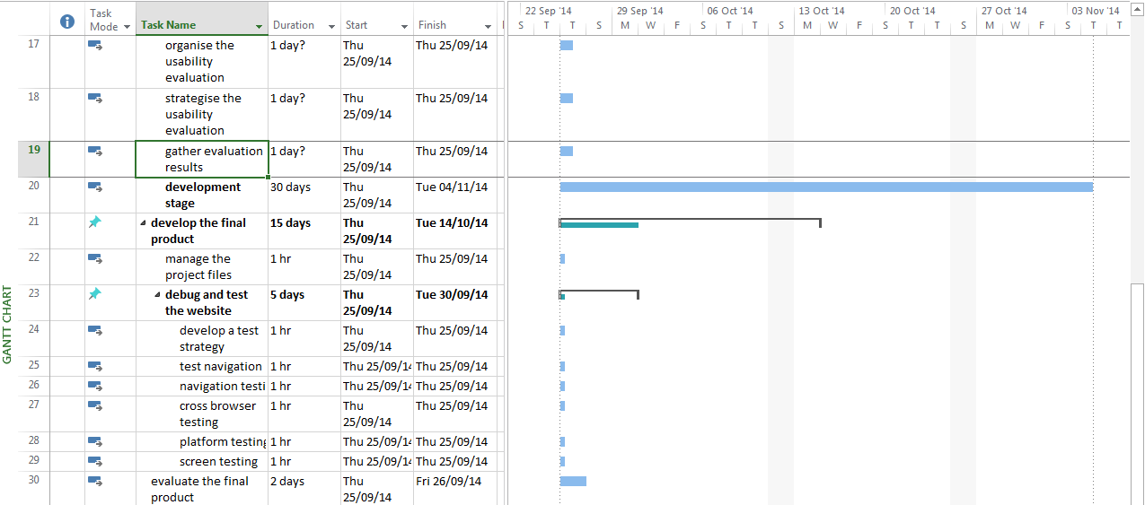

Project plan final

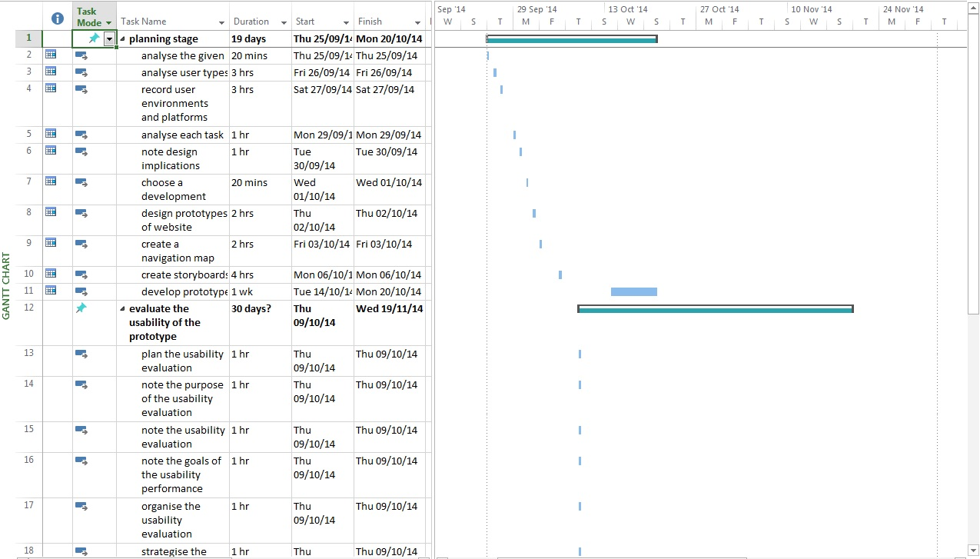
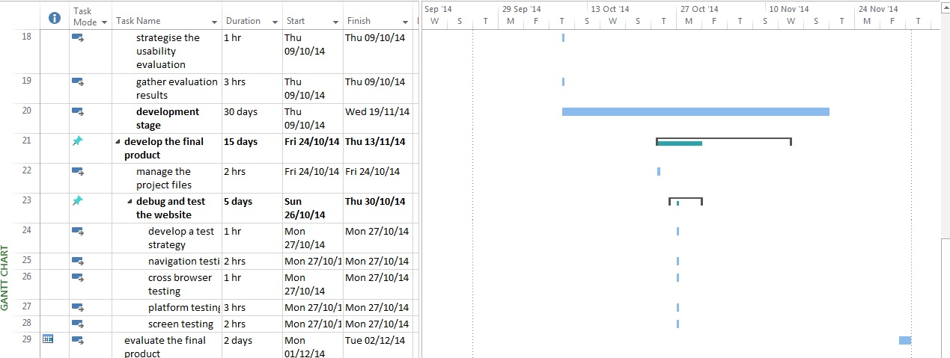

Designing the Prototype

Usability Guideline | Justification of how it will be implemented in to website
consistency | The same font, and colour scheme throughout the website to maintain the user’s familiarity of the website as not doing so could cause the user to become confused or lost within the website.
Help and documentation | Include a user guide to help users, use the website.
System status info | Alert user to where they are within the website or any process which is currently in action.
User control | Ability to exit if user enters data by mistake
Error prevention | Provide message asking user to confirm their selection If they enter data.
Easy to read font | Use of a san serif font to maintain the aesthetics of the website through a minimalist design.

Navigation map

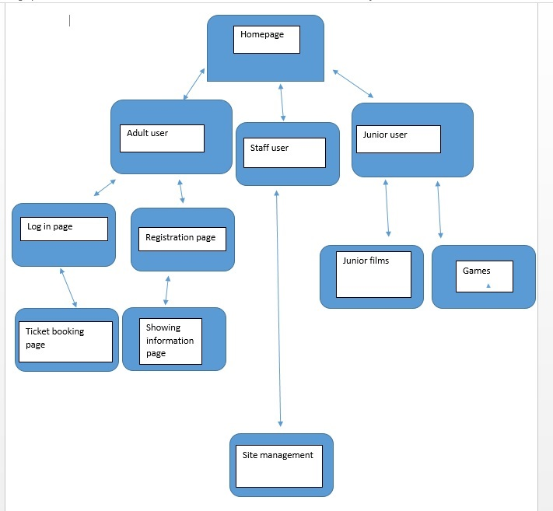

Storyboards
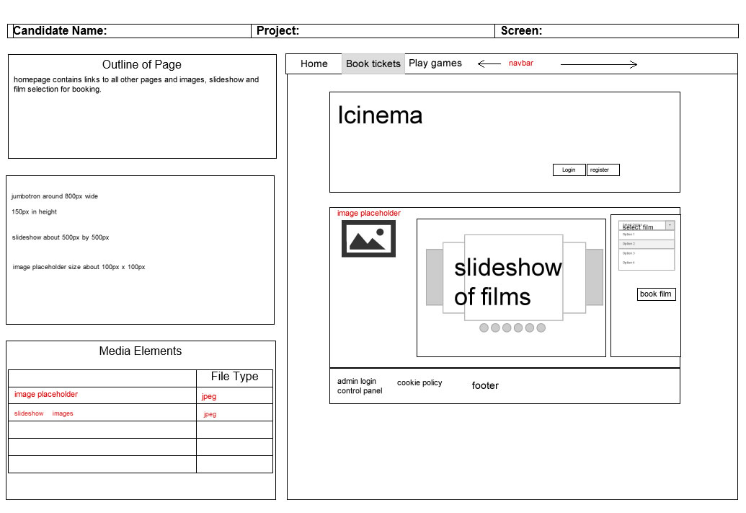

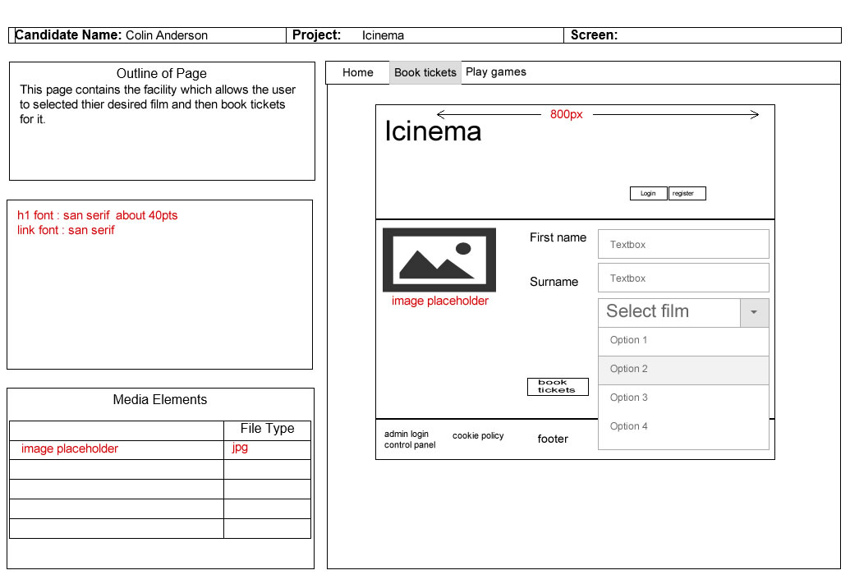

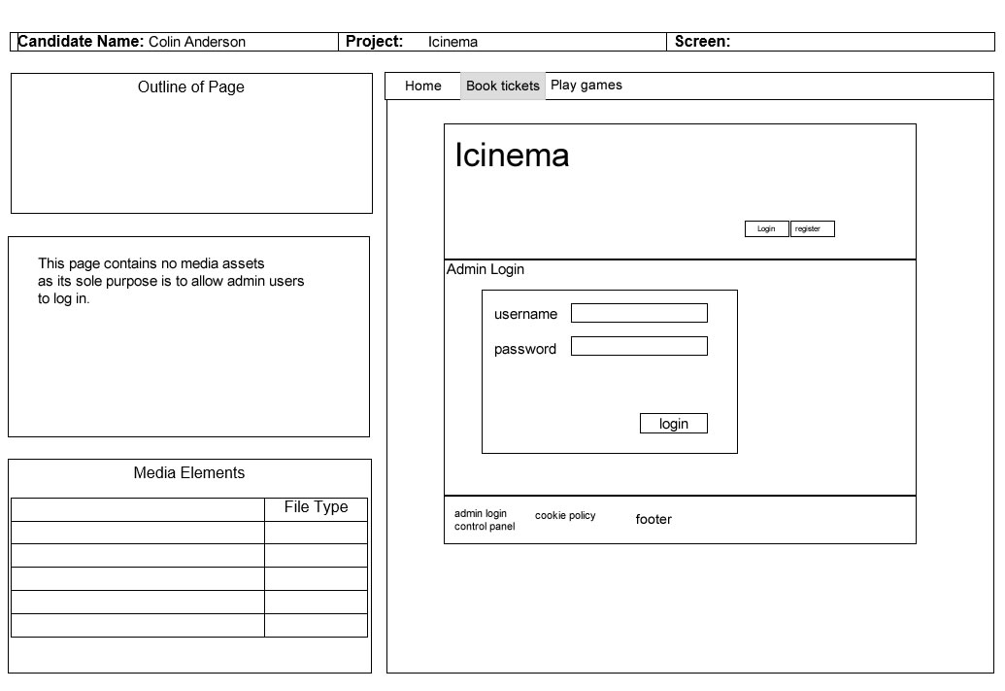

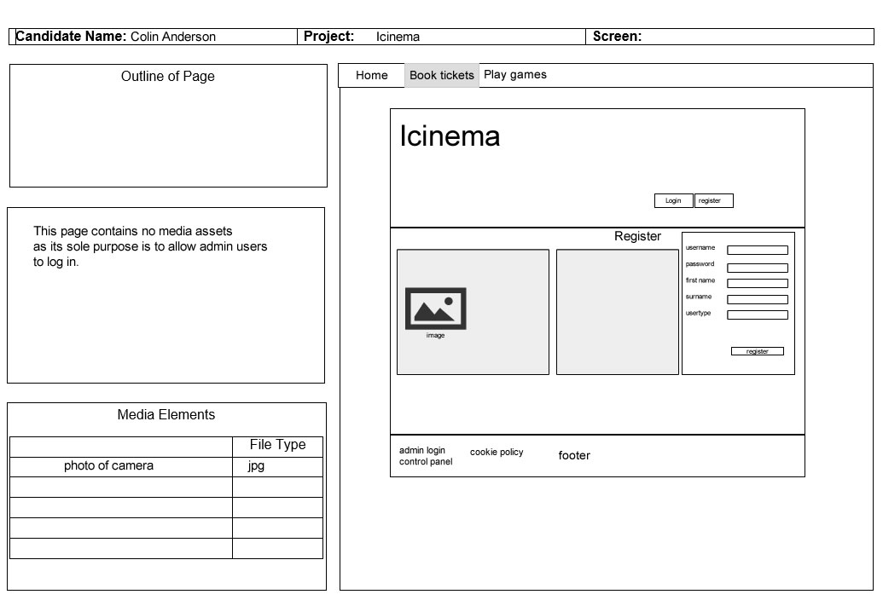

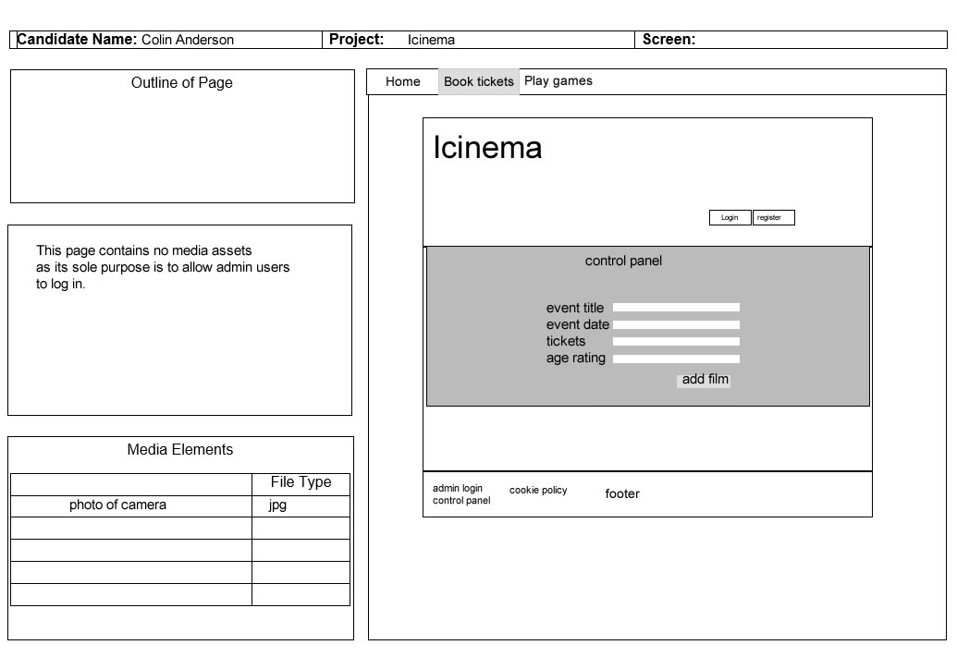

Mobile storyboard
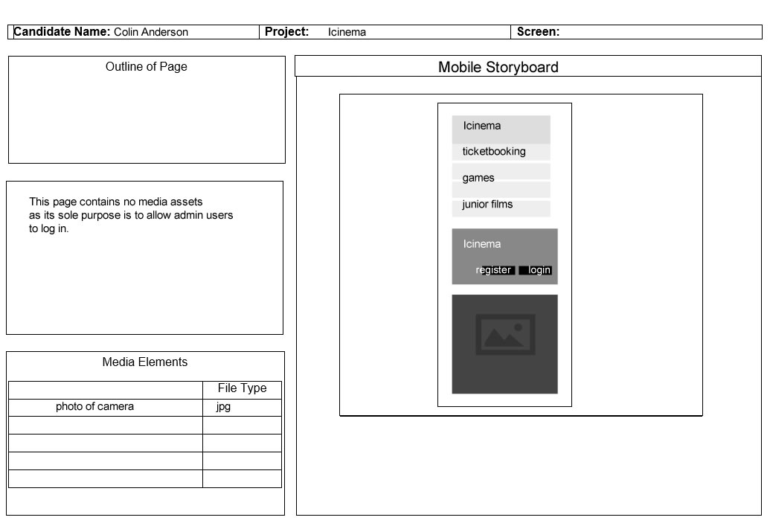

Prototype Development

Usability evaluation of prototype

Usability Evaluation Plan

Purpose of the Usability Evaluation

The purpose of the usability evaluation is to show how easy the prototype is to use in terms of its usability and accessibility. The evaluation should highlight any areas of the website which the user might find difficult to use. The benefits of this testing will allow the suggested improvements to be made within the final stage of development in the long term the more usable the final product is, the more likely users are to return to the website. With the feedback gained from the evaluation I will be able to know what needs to be improved. Carrying out this evaluation in the earlier stages of development should make it easier to make changes to improve the prototype making it more usable rather than in the final build of the product. Other advantages of the effectiveness of the evaluation include the final product being usable which in turn would bring more customers to the website, build a good reputation for the brand/company, and would most likely increase income revenue through sales.

Usability Evaluation Strategy

The usability evaluation will be run using several subjects who will be observed using the prototype to test it for its usability. This will show how effective the prototype is in functioning the way it should and will highlight any problems within the prototype. The sample users will be tasked with simple tasks such as registering, logging in and booking tickets to see that these functions work and the user is able to complete them as easily as possible. With the results taken from the usability evaluation the feedback and observations of performance as references to help improve the development of the final product.

Usability Performance Goals
The time it takes the users to complete each task will be monitored. Each task should be completed easily to ensure the usability goals are met. If the users fail to complete a task or find it difficult to do so, the area of the website which is the issue will be noted and improved for the final product.

Setting up the usability evaluation session
The test will take place at 12:20 on the 16th of December in room 302. Computers with hardware such as a mouse and keyboard and with an internet connection will be required as there is to be an online questionnaire which will be used to gain the sample users answers and comments about the usability of the website. The connection will also be required to view the website as it requires to connect to a server for the PHP functionality.

Usability Evaluation Sample
There will be 7 participants in one session, each participant selected at random this way the test will be effective in showing a range of different levels of computer literacy and how these different levels cope with using the prototype.

How the evaluation will be conducted
Step by step running of the usability evaluation.
- The sample user will be selected at random
- (Each of the tasks will be observed and notes will be taken about how the user performs when using website, for example each task will be timed to see how long it takes)
- The sample user will attempt to register to the website
- The sample user will then attempt to log in to the website
- The sample user will then attempt to book tickets to the website
- The sample user will then take the usability questionnaire
- Each result of the questionnaires taken will be taken into account

Post Test Deliverables

Questionnaire results :

Question 1: How difficult was it to navigate to your desired page?

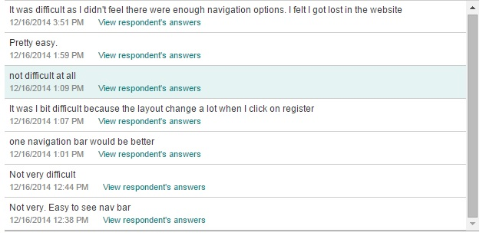

Question 2 : if you could improve the website in one way what would you do ? (answers on next page)

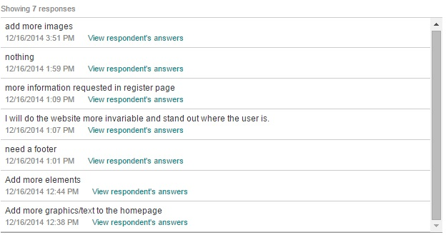

Question 3 how easy/difficult was it to register with the website?

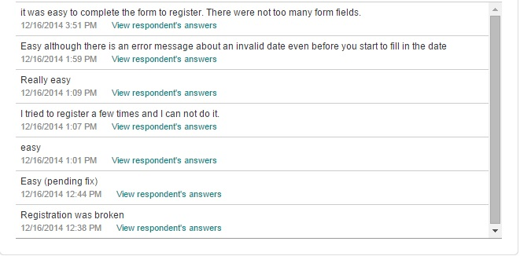

Question 4 : how easy/difficult was it to log in ?

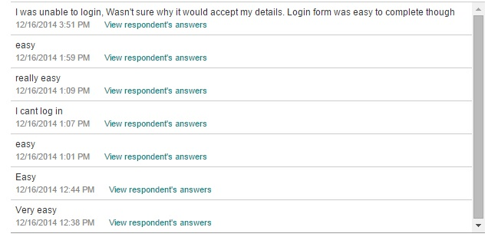

Question 5: was the font easy to read?

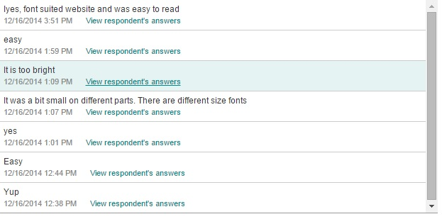

Question 6: How responsive was the website as a whole?

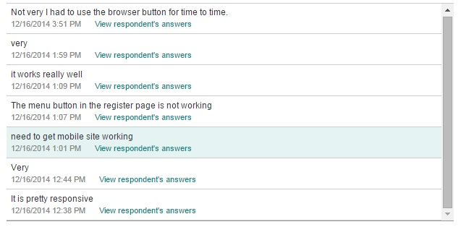

Question 7: What age group do you fall into ?

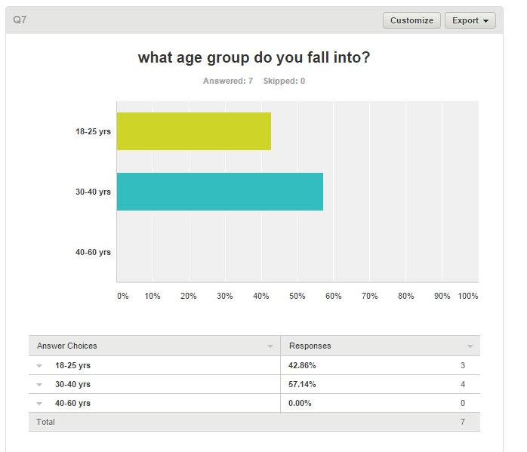

Analysis of the data collected

Analysis of the results of the testing and report on your conclusions.
From the results of the testing it appears that the majority of the sample users found that the website was easy to navigate although it must be addressed that some of the users found that they had to use their browsers back buttons “from time to time”. Most of the users suggested that the website required more images. One of the users commented that the font changed size on different pages, this will be addressed in the change log as the readability of the font is greatly important in the usability. Many of the testers used were experienced in web development. In the future I think it would have been more appropriate to have users who were regular cinema goers or people affiliated with a cinema company.

Usability Change Log

Changes that must be made include the fixing of the registration page as it was linked to the wrong script. Also some users found the font colour to be too bright, to fix this the colour will be changed to a colour more suitable. The website will also be altered so that a mobile version is available as one of the sample users requested mobile compatibility. The addition of more images will be implemented as requested by the sample users. I will also try to implement an age gate to improve upon the membership system although this might not be possible to do within the given time.

Development of the product

Management of project files

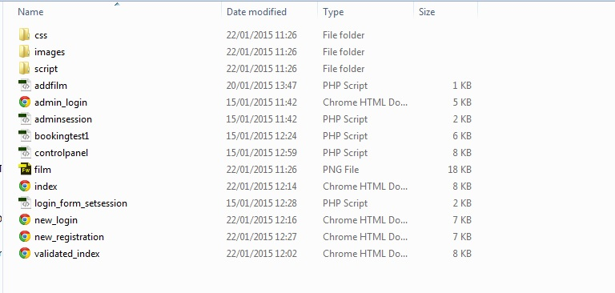

When managing your project you should take into consideration any files which you may need for editing later and final versions of files. An asset list may also help you to catalogue all files used in the completed project.

Debug and test

User input testing

Register form

formfield name | formfield name
Username | Password | Expected Result | Actual Result | Comment
Data entered | Data entered
user | 2222 | Invalid username | Doesn’t login | Works as expected
Wendy | Blank | Validation highlights field left blank | Validation highlights field left blank | Works as expected
“Blank” | 2222 | Validation highlights field left blank | Fails to login | Validation added to username form field to prevent it being left blank
“LEFT BLANK” | password | The form will alert the user that the username requires data to be entered into the field | The script prevents the user from leaving form field blank | Works as expected
Adult | Adult | The user should login | The user logs in | As expected
Child | Child | The user should login | The user can log in | As expected

Login form
Abnormal and normal testing conditions

 | Formfield title | Formfield title | result
 | Username | Password | result
Data entered | (blank) | (blank) | The form validation should show a message stating that the form fields must be filled in
Data entered | Adult | Adult | The user logs in successfully
Data entered | register1 | Register1 | The user logs in successfully

Admin control panel testing

Publish and Test

Test Strategy

To test the functionality such as the register and login forms, first valid data will be entered to confirm that the product works under normal conditions. Following this abnormal data such as entering numbers into text fields will be tested to see how the product functions under abnormal conditions. Depending on how the website reacts to this data, some form validation will probably be required to be to prevent users from entering invalid data.
I plan to test the website by entering the website address of each page of the website in to each browser and then navigating to the adjacent pages. Each page will also be tested on as many platforms as possible such as windows and mac if possible.
Accessibility of the website will be tested using http://achecker.ca/checker/index.php an online accessibility checker. This will be tested by the developer. Any areas highlighted by this website will be used to improve the website’s accessibility.
Some platform testing will be carried out using Screenfly at http://quirktools.com/screenfly/. This will be carried out by entered the site url into the address box on Screenfly and then selecting the type of screen to test it on using the website’s interface. This will provide a good idea of how the website will look on different platforms such as mobile, tablet and television screens.

Navigation testing

 | index.html | Bookingtest2.php | contact.php | games.html | Controlpanel.php | Adminlogin.html
index.html | Does as expected | If user isn’t logged in the user is directed to login page | As expected | As expected | User is redirected if not logged in as admin | Index was linked to old page admin_login.html
Adminlogin.html | As exected | If user isn’t logged in the user is directed to login page | As expected | As expected | User is redirected if not logged in as admin | As expected
Bookingtest2.php | As expected | If user isn’t logged in the user is directed to login page | As expected | As expected | User is redirected if not logged in as admin | As expected
register.html | As expected | If user isn’t logged in the user is directed to login page | As expected | As expected | User is redirected if not logged in as admin | As expected
Controlpanel.html | As expected | If user isn’t logged in the user is directed to login page | As expected | As expected | User is redirected if not logged in as admin | As expected
games.html | As expected | If user isn’t logged in the user is directed to login page | As expected | As expected | User is redirected if not logged in as admin | As expected

Test Description | Expected Result | Actual Result | Comment
Ticket Booking | User is able to book tickets for selected movie | User is able to book tickets for selected movie | Works as expected
Restricting child member access to booking page | Child member is redirected to child area when they try and access booking page | Child member can’t access bookings page | Added a header function redirecting members logged in as children to the child area
Admin update database by adding films to it | Admin can add films to database | Admin can add films to database using admin control panel | Works as expected
Ticket printing | User should be able to click print to print a copy of their order | User is able to click print to print a copy of their order | Works as expected
User is able to register as an adult member | User can register as an adult | User is able to register and then use registered username and password combination to login | Works as expected

Cross browser testing
The website will be tested on the following browsers because according to w3c these are the most popular in terms of frequency of use. The purpose of testing on each browser is to highlight any incompatible sections of the website which might function on one browser but not another.

Page tested | Internet explorer | Google chrome | Mozilla firefox
Index.html | Page displayed correctly | Page displayed correctly  Page displayed correctly  Page displayed correctly
Bookingtest2.php | - Page displayed correctly |  | Page displayed correctly
Games.html | - Page displayed correctly |  | - Page displayed correctly
Register.html | - Was readable, links functioned correctly  - Website tested at 1280x1024 resolution | Page displayed correctly | - Page displayed correctly
Login.html | - Page displayed correctly | - Page displayed correctly | Page displayed correctly
Controlpanel.php | - Page displayed correctly | - Page displayed correctly | - Page displayed correctly
Adminlogin.html | - Page displayed correctly | - Page displayed correctly | - Page displayed correctly

Platforms

Page tested | Desktop PC | Mobile (tested on nokia Lumia 610)
Index.html | - Page displayed correctly | - Page displayed correctly  - Page displayed correctly  - Page displayed correctly
Bookingtest2.php | - Page displayed correctly
Games.html | - Page displayed correctly
Register.html | - Was readable, links functioned correctly  - Website tested at 1280x1024 resolution | - Website loads slowly(could be broadband issue unrelated to hardware)  - Scales to suit mobile browser
Login.html | - Page displayed correctly | - Page displayed correctly
Adminlogin.html | - Page displayed correctly | - Page displayed correctly
Controlpanel.php | - Page displayed correctly | - Page displayed correctly

Screens

Page tested | Desktop PC | Mobile (tested on nokia Lumia 610)
Index.html | - Page displayed correctly | - Page displayed correctly  - Page displayed correctly  - Page displayed correctly
Bookingtest2.php | - Page displayed correctly
Games.html | - Page displayed correctly
Register.html | - Was readable, links functioned correctly  - Website tested at 1280x1024 resolution | - Website loads slowly(could be broadband issue unrelated to hardware)  - Scales to suit mobile browser
Login.html | - Page displayed correctly | - Page displayed correctly
Adminlogin.html | - Page displayed correctly | - Page displayed correctly
Controlpanel.php | - Page displayed correctly | - Page displayed correctly

Test Plan
Expanding on the test strategy. Document all information required to successfully carry out all testing.

- The functionality of the website requires to be tested. The functionality being the ability to purchase a film ticket, the ability to register as a member and to use the login system. In order to test the product a test sample of users must be gathered, ideally this group of people will fit the demographic of the target audience of the product. The testing will involve a number of tasks which will be designed to test the functionality, carried out by the test sample and then recorded from observation of how well each task is performed.

An example of a task that will be carried out during testing is the functionality of the ticket booking system
- To test the ability of purchasing a ticket the sample users will be asked to first
- Log into the website
- Navigate to the ticketbooking page
- Select a film
- Then enter their details into the text fields provided
- Then click submit to book a ticket

- This test will be carried out in room 114m at 11.00am
- After the user has carried out the task the user will be asked to fill out a questionnaire regarding their experience
- The purpose of recording the results is to use the data to improve the website if the users struggle to carry out the tasks
Throughout the development of the project a method of white box testing has been implemented. A black box method will be used in the final testing of the product as I feel it is the most effective method to test the usability and functionality of the final product.

- The test will take place in room 114m at 11.00am
- A group of sample users will test the usability of the site by completing various tasks such as logging in, booking tickets and registering.
- The time that each task takes to complete will be recorded and will be used as an example for judging how well the product functions as well as how accessible it is to users who are unfamiliar with product. This method will also be effective in testing the functionality of the product.
- After the users have tested the product they will be asked to fill out a questionnaire regarding their experience using the product
- Any data recorded could potentially help improve the website by highlighting areas of error or malfunction.

Publish the product
Deploy the solution to the chosen delivery medium. Produce relevant end-user guide and help information. Provide url and screen shots of FileZilla.

User-guide

To login as an admin for testing purposes the username is admin and password is password.

To book tickets as a member of the website the user must first register. Following this the user must navigate to the login page and then login. Once the user is logged in, the user must then navigate to the ticketbooking page. From the booking page the user must enter details of the film title, date of showing, first name, sir name and the number of tickets desired.

For admins to login the hyperlink is located in the footer of each page. The user must click the hyperlink to navigate to the admin login page. From here the admin must enter their login details into the boxes provided and click submit. Once logged in the admin has the ability to add films to the website database. To do this the admin must enter the film title, the date of showing and number of tickets available.

Link to website http://webdev.edinburghcollege.ac.uk/~HNDCANDERSON2/Icinema

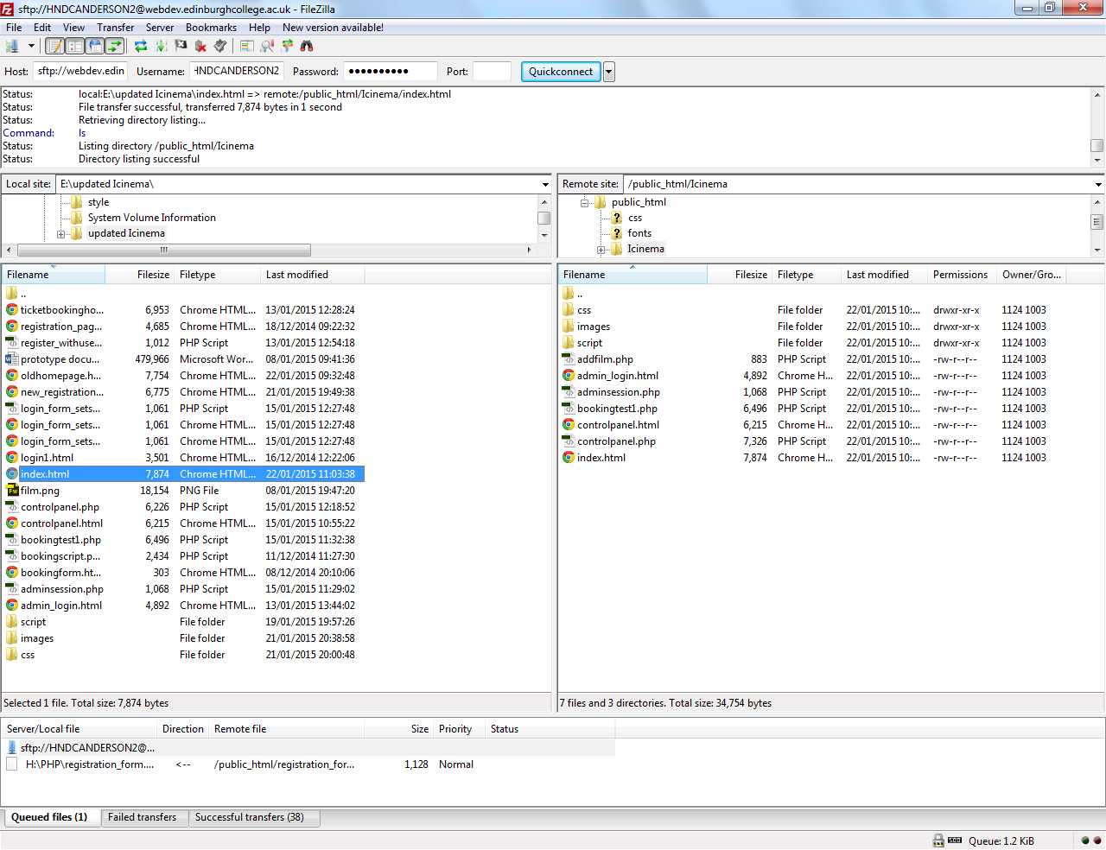

Testing report

The results of the testing outlined that most of the time the product functions as it should. Some errors that needed to be addressed were pages that were directing to older versions of other pages. This will be fixed by either changing the names of the files to the correct name or changing the name of the link in the html.

Evaluation

Evaluating the final product

Planning stage

For the planning of the website layout I used adobe fireworks to create storyboards. I found this program efficient in this purpose as I have experience in using it which allowed me to create the storyboards quickly which in turn allowed more time for other parts of the planning stage.
To create the navigation map I the shape tools in Microsoft word, I chose this program because I have used it in the past to create navigation maps and because of this I felt the familiarity would aid me in creating an efficient enough navigation map. I believe this section was done successfully as the navigation map displays all necessary information about the navigation of the website.

Usability testing
The usability testing was carried out using people unfamiliar with the website. This was effective as it allowed me to see areas which needed to be improved from an unbiased perspective. The website is good in terms of usability as it provides users with feedback when they enter data into the forms. This is also enforced in some of the forms which use Javascript form validation which means the user cannot enter submit invalid data into the forms. The use of headings is also effective on the website as they indicate the title of each page and would therefore help users recognise which page they are on. There are also alt tags provided which are appropriate for audio text reading software for sight impaired users or if an image is missing it would indicate what the content of the missing image is supposed to be. The forms on the website are also optimised for usability because the labels of each form clearly indicate what the content of each box should be. The testing could have been improved if it was possible to get access to an apple mac.

Improvements for future projects
More Javascript validation of forms would have also been helpful although this wouldn’t have been feasible in the time allowed. I will definitely include Javascript form validation in future development projects. This validation could be helpful in preventing users enter a negative number into the number of tickets required.I have had feedback from some users which stated that the website text was difficult to read during the testing stage. To address this I increased the contrast between the background and the text as well as choosing a font which I felt was easier to read. In the future I think It would be more effective to use the program “Gliffy” to make more professional looking diagrams for storyboards and navigation maps. One area in which the website does not meet the required specifications is in the junior section of the website as it was not possible to create a search facility for age suitable films because an age gate was not included in the final website. In the future I would like to implement an age gate to improve accessibility of future projects.

Personal improvement

Throughout the project I feel as though my programming skills in PHP had improved, the main reason for this was because I kept accidentally overwriting my files resulting in me having to redo the coding. I think this repetition has improved my PHP coding though. I think this issue was because I had many files with similar titles and was unsure of which files were the functioning ones. This was an issue with my file management skills I believe and it had a severe effect on the amount of time I had available to develop my website. In the future I would try and organise my files better as doing so would probably give me more time for development of products. My use of PHPmyadmin has improved as I have become more familiar with using it to create databases for the product. I think the writing of the documentation for the project has improved my report writing skills because of the repetition. If I had more time I would have liked to create a better logo for the website. I would have most likely used adobe illustrator as it allows the creation of scalable, high resolution images in the form of vectors.

Conclusion
Over all the product does adhere to the original brief in that it is made for three different levels of membership. It also has facilities that allow users to register to become members. There is also a facility which allows users to print off their tickets which was required by the brief. A games page has been provided to adhere to the junior members. The ability for staff members to add films to the database was also implemented as required by the brief.

Evaluating the project

Planning
The task analysis was created efficiently with a table layout indicating the task and the steps used to complete each task. I felt this was effective as it visually showed the content of the task and what was required to complete the task. The navigation map was completed using the shape feature in Microsoft word. This seemed like the simplest program to use as I have previous experience in using it to create navigation maps.

Finished solution against original requirements

As required by the brief, the final product meets the majority of the requirements.
The brief required that “ Junior members would like a website where they can find out about age suitable films” the final website meets this criteria as the junior films page shows all age suitable films without the user having to log in. A games page was also required by the brief. The website meets this requirement as the games page contains two games, one which is “quiz based” required by the brief. Adult members can register, login and then view showing dates and ticket stock. If logged in, the user can then book tickets for films. There is also the ability to “print off ‘showing’ information as required by the brief. In addition to the adult and child sections, there is also an admin panel from which staff users can add films to the database and also view member’s information such as first name and username. To enable this functionality the user must be logged in as an admin. Admin users also have the ability to remove users from the database using the control panel. The website meets the brief’s requirement of having “form validation and error handling” within most of the text fields of the forms. The website is well optimised for mobile use as it has bootstrap’s scaling capabilities. Overall the website meets the majority of the brief’s requirements.

Development stage
During the development I rarely felt the need to refer to the planning documentation. I think the most useful part of the documentation was the user feedback. I found it helpful because it highlighted areas of the website which were problematic for users which I would not notice because of my familiarity of the website. For most of the PHP programming I used Dreamweaver, this program was efficient because it gave produced feedback on whether the code written was valid. In the future I would have also liked to use bootstrap more to my advantage in the development stage, although I am still quite inexperienced in using it.

Project management
I think In the future I wouldn’t use a gannt chart during the project as creating one ate into the development time of the product. I also felt as though Microsoft project wasn’t efficient enough to use in order to create the gaant chart. I also seen the storyboards as unhelpful because I feel the need to use them in the development of the product and they didn’t help me improve the product as the website was constantly changing and doesn’t resemble the original layout plan seen in the storyboards. If I had managed my time more efficiently to complete the documentation required, I think it would have resulted in more time allowed to create a better website.

Effective | Valid | Interactive
Efficient | Appropriate | Supportive
On-going | Realises | Encouraging
Comprehensive | Purposeful | Emerging
Good/Poor | Valuable | Diligent
Successful | Disadvantage | Constructive
Beneficial | Advantageous | Imperative
Strong/Weak | Honest | Excellent
Restrictive | Systematic | Planned
Positive | Clear | Thorough
Collaborative | Exemplified | Identified
Responsive | Involved | Regular
Healthy | Meaningful | Full and Frank
Limited | Adopted | Reflective
Expressed

Evaluation Words

Submission Check List
What is required to be submitted.
- Fully completed report
- Prototype
- Finished website
- User Guide
- Gantt Charts (or alternative project management tool) x 2, start and end of project.

